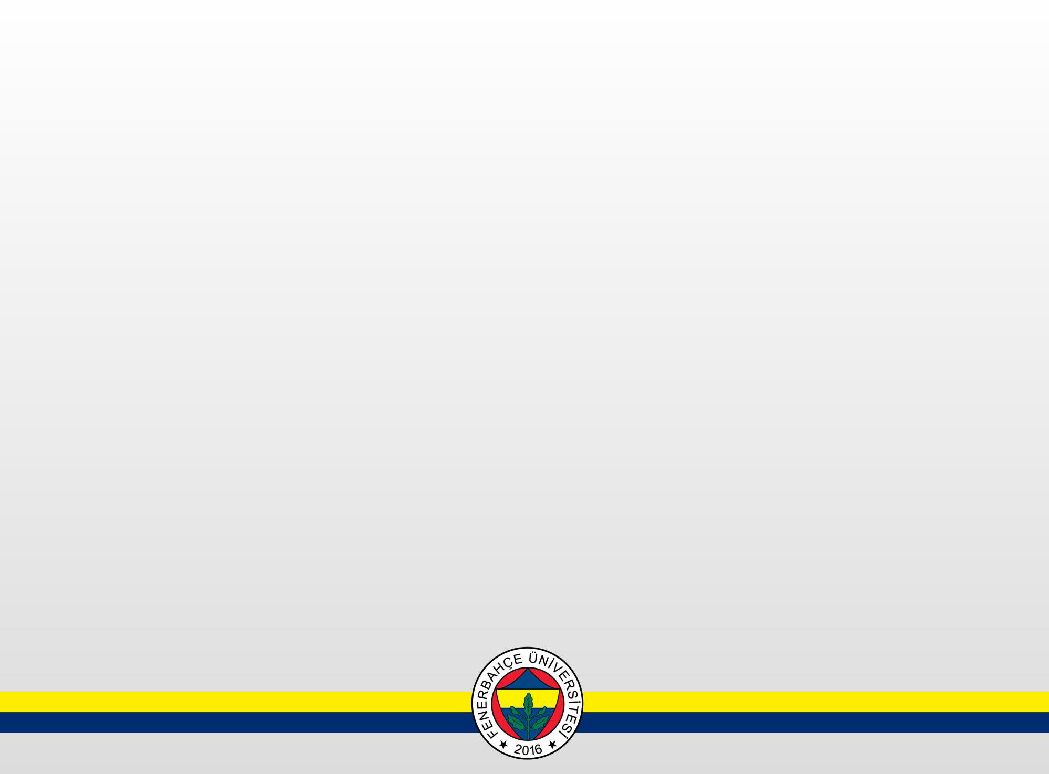
Ders Programı / Schedule 2024-2025 (Bahar/Spring)
Siyaset Bilimi ve Uluslararası İlişkiler (1)

Saatler / Hours | Pazartesi / Monday | Salı / Tuesday | Çarşamba / Wednesday | Perşembe / Thursday | Cuma / Friday
09.00-09.50 | ENG104  Advanced English II  (Section 1) | COMP104  Information Technologies |  | TURK108  Turkish Language II
10.00-10.50
11.00-11.50 | TURK104  Turkish Language II  (Section1)
12.00-12.50 |  | IR102  Introduction to International Relations
13.00-13.50 |  |  | HIST112  History of Civilizations II | ECON 102  Principles of Macroeconomics
14.00-14.50 | PSYC134  Fundamentals of Psychology
15.00-15.50
16.00-16.50
17.00-17.50
18.00-18.50
19.00-19.50
20.00-20.50
21.00-21.50

Ders Programı / Schedule 2024-2025 (Bahar/Spring)
Siyaset Bilimi ve Uluslararası İlişkiler (2)

Saatler / Hours | Pazartesi / Monday | Salı / Tuesday | Çarşamba / Wednesday | Perşembe / Thursday | Cuma / Friday | Cumartesi/ Saturday
09.00-09.50 | IR204  International Relations Theories |  | POLS202  Politics in Turkey | STAT240  Statistics
10.00-10.50
11.00-11.50
12.00-12.50
13.00-13.50 |  | STAT280  Research Methods in Social Sciences |  | LAW 234  Constitutional Law |  | HIST204  Ataturk's Principles and The History of Turkish Renovation II
14.00-14.50
15.00-15.50
16.00-16.50
17.00-17.50
18.00-18.50
19.00-19.50
20.00-20.50
21.00-21.50

Ders Programı / Schedule 2024-2025 (Bahar/Spring)
Siyaset Bilimi ve Uluslararası İlişkiler (3)

Saatler / Hours | Pazartesi / Monday | Salı / Tuesday | Çarşamba / Wednesday | Perşembe / Thursday | Cuma / Friday
09.00-09.50 |  | POLS304  Contemporary World Politics | IR467  City Diplomacy | POLS466 Cyber Politics and Emerging Technologies
10.00-10.50
11.00-11.50
12.00-12.50
13.00-13.50 |  | POLS468  POLS468  Economic and Social History of Turkey | IR302  International Organizations | POLS388  Social Anthropology
14.00-14.50 | IR462 The Protection and Promotion of Human Rights in the EU II
15.00-15.50
16.00-16.50
17.00-17.50
18.00-18.50
19.00-19.50
20.00-20.50
21.00-21.50

Ders Programı / Schedule 2024-2025 (Bahar/Spring)
Siyaset Bilimi ve Uluslararası İlişkiler (4)

Saatler / Hours | Pazartesi / Monday | Salı / Tuesday | Çarşamba / Wednesday | Perşembe / Thursday | Cuma / Friday
09.00-09.50 | IR404  Current Issues in Turkish Foreign Policy |  | IR467  City Diplomacy | POLS466 Cyber Politics and Emerging Technologies
10.00-10.50
11.00-11.50
12.00-12.50
13.00-13.50 |  | POLS468  Economic and Social History of Turkey |  | POLS388  Social Anthropology
14.00-14.50 | IR462 The Protection and Promotion of Human Rights in the EU II
15.00-15.50
16.00-16.50
17.00-17.50
18.00-18.50
19.00-19.50
20.00-20.50
21.00-21.50

